Lab 0   
Pengzhao Zhu  
Section: 112D

# Prelab Questions

1. How late can you arrive for lab and still be admitted?

**If student arrive more than 20 minutes after lab begins, student will not be admitted.**

1. How late can you arrive for lab and still be allowed to take the lab quiz?

**If student arrive more than 10 minutes after lab begins, student will not be eligbile to take the lab quiz.**

1. When are your prelab submissions to Canvas due?

**Prelab submissions must be turned in least 15 minutes before the start of lab.**

1. What minimum lab average is required to be eligible to pass the course?

**An overall lab grade of 65% or better is required in order to be eligible to pass the course.**

1. What is the lab makeup policy if you miss a single lab?

**The first missed lab will be the dropped lab. Student will not be officially making up the lab. There is rarely an excuse that will allow you to reschedule your first missed lab other than an exam in another course. The documentation for the first missed lab is not needed unless there is a second missed lab. At that time, student must turn in documentation for both missed lab.**

1. Can you drop this lab if ... a) you overslept? b) a project for another class is due?

**Yes, you can drop the lab if you overslept or there is a project for another class. It will be the dropped lab. For follow up details, please refer to question 5 above.**

1. When soldering a wire to a pin, what should the soldering iron touch and what should the un-melted solder touch?

**The un-melted solder is applied at the joint. The tip of the soldering iron should be positioned so that it touches both the surface of the PCB and the lead being soldered. The solder should be on the opposite side of the soldering iron. Please see image below for a visual description.**

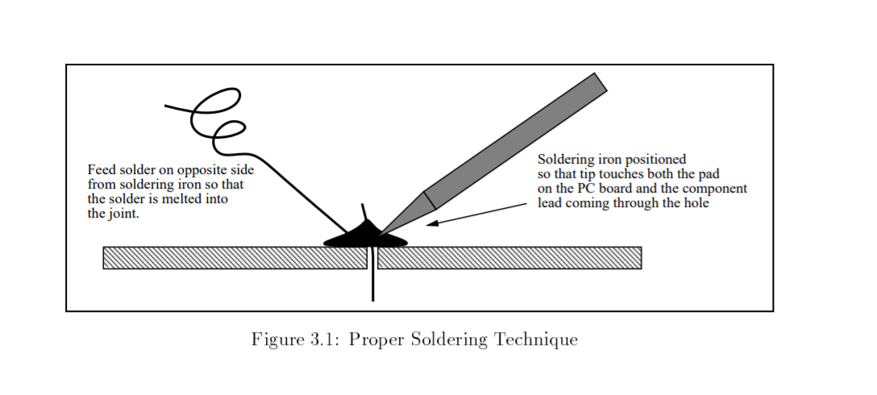

# Problem Encountered

Due to the fact that this is the first lab and no codes/programs were written. No problems were encountered.

# Future Work/Application

The lab policy documents and syllabus will help us understand the goals and purposes of this class. The lab session consists of build/solder the PCB board will allow us to use the microprocessor in a variety of real-world applications (in future labs). Due to the fact that is the first lab, not much work were performed.

# Schematic

N/A

# Pseudocode/Flowcharts

N/A

# Program Code

N/A

# Appendix

N/A